To use your email after the change to mail.falconcrestaviation.com:
If you use Thunderbird as you email client:
Start Thunderbird.
INBOUND EMAIL SETTINGSIn the top line, click on TOOLS and then SETTINGS:
Click on your email account for Falcon Crest Aviation (like dmount@falconcrestaviation.com)
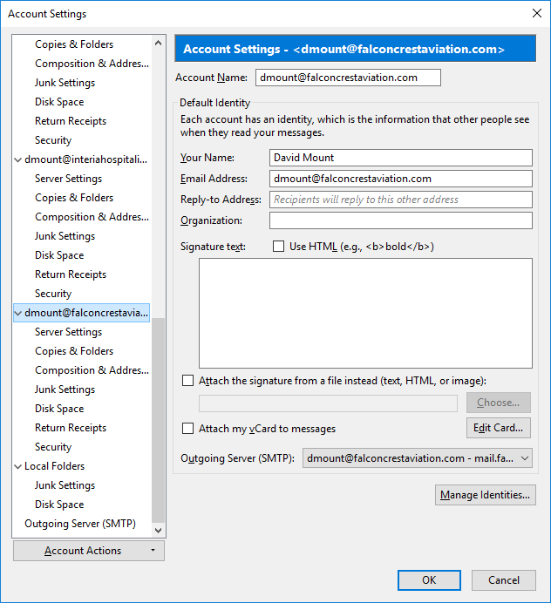
Then right beneath your email name, click on server settings.
Change the server name from postfix.consultsgi.com to:
mail.falconcrestaviation.com
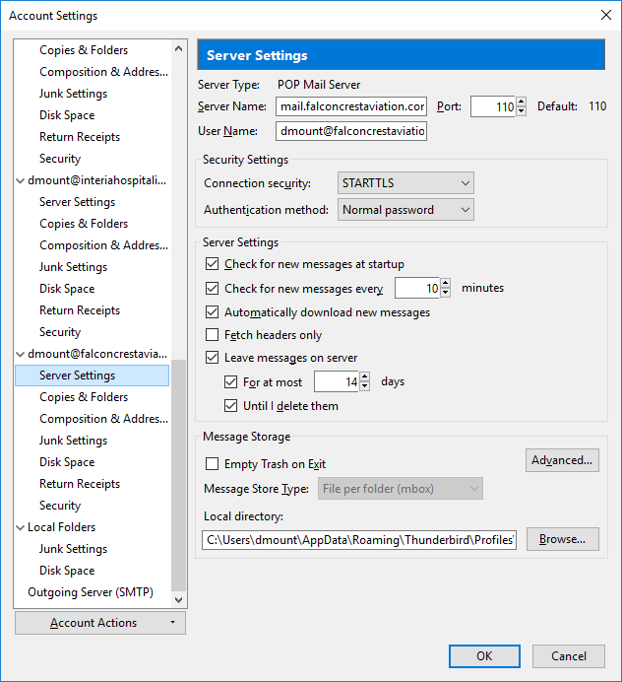
In the panel on the left, scroll down to "OUTGOING MAIL SERVER" and click on it.
Select the server in the right panel that agrees with you falcon crest aviation email.
Make the following changes:
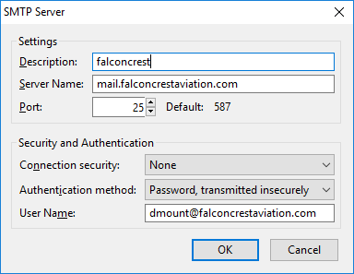
Click the OK button.
Stop and restart Thunderbird.

