New Email Server Setup Instructions

- In Outlook, click on File then click on Account Settings then again on Account Settings underneath it.
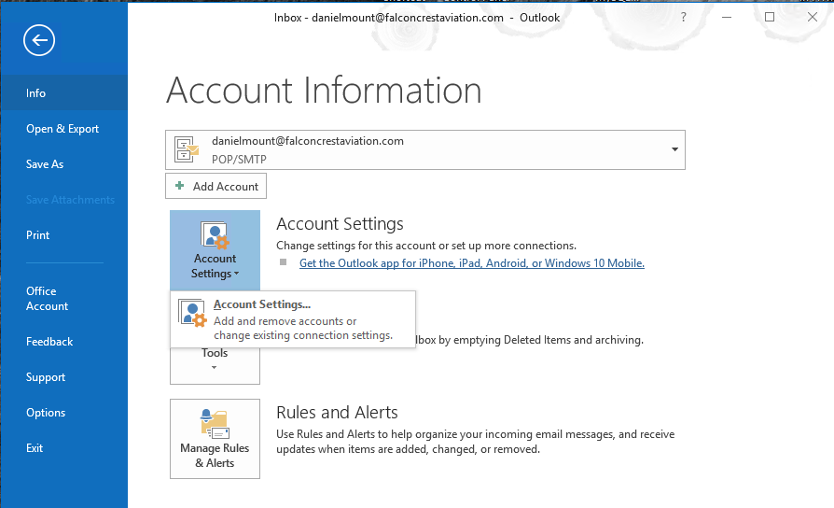

- Click on Change…
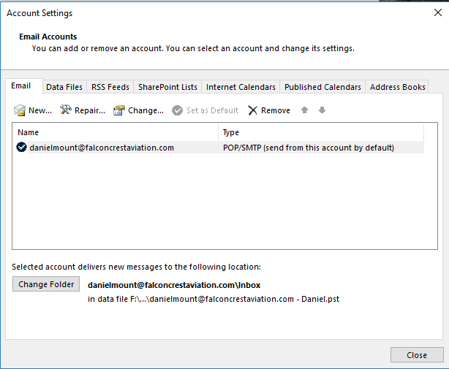

- Change both the Incoming mail server: and the Outgoing mail server (SMTP) to mail.falconcrestaviation.com
- Then click on More Settings …
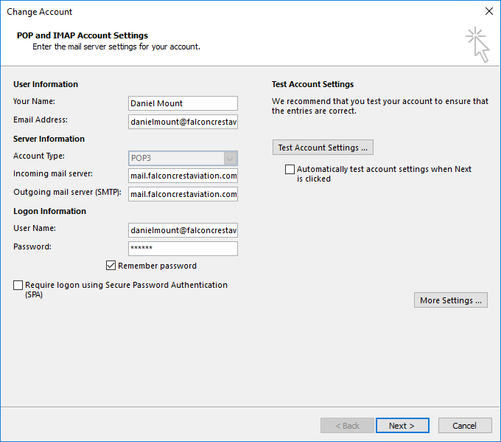

- Click on the Outgoing Server tab and Check the My outgoing server (SMTP) requires authentication box.
  - Make sure Use same settings as my incoming mail server is selected.
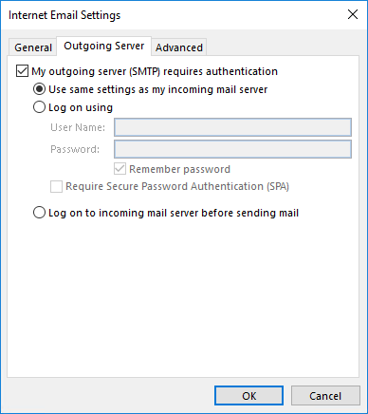
- Click on the Advanced tab and set:
  - Incoming server (POP3) – 995
  - Check the box for This server requires an encrypted connection (SSL)
  - Outgoing server (SMTP) – 2525
  - Use the following type of encrypted connection – Auto
- Click on OK
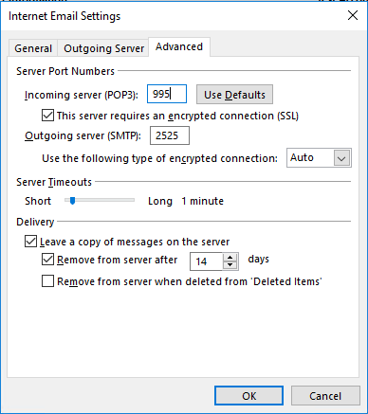

- Click on Next
- Click on Finish. You’re done!
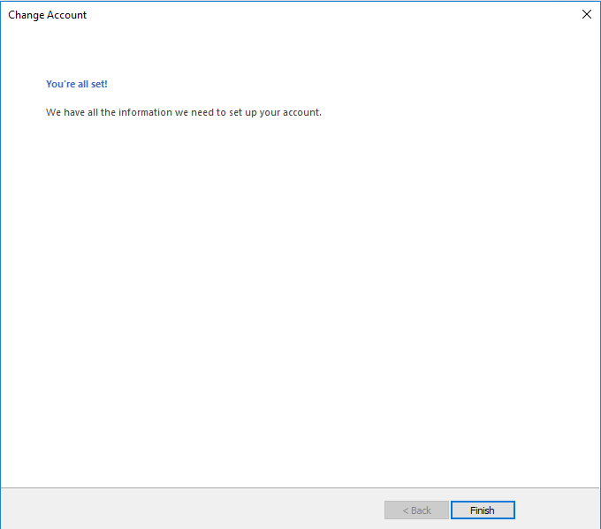

Note: You may get an Internet Security Warning for the first few days. Just click on Yes to continue using this server. This will get cleared up as we get the new certificate installed.

